Change Request: Asset Disposal Enhancement
Module: Asset Management
Screen: Asset Disposal Screen
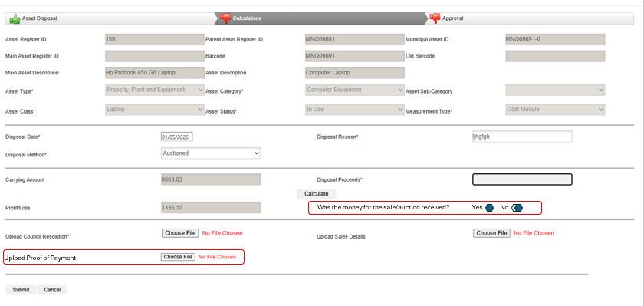

1. Addition of Payment Confirmation Field
- Introduce a new field within the Calculation Section labelled:
“Was the money for the sale/auction received?”
- Provide the user with two selectable options using radio buttons:
  - Yes
  - No
2. Conditional Proof of Payment Upload
- If the user selects “Yes”, the system must:
  - Display an upload control to allow the user to submit Proof of Payment documentation.
  - Ensure the upload control accepts standard supported file formats (e.g., PDF, JPEG, PNG).
  - Upload op Proof of Payment must be a compulsory field.
- If the user selects “No”, the system must:
  - Introduce a new field within the Calculation Section labelled:
  - “Do you want to inform Debtors to create a Sundry Account?”
    - Provide the user with two selectable options using radio buttons:
      - Yes
      - No
  - If the user selects “No”, continue with normal processes associated with the disposal screen.
  - If the user selects “Yes”, send out a pre setup email to a specific email address. (see email settings below)
  - Ensure a copy of the email (in PDF format, is linked to the specific asset Transaction in the Asset Document Tab
3. Document Storage and Linking
- All uploaded documentation must:
  - Be stored within the Asset Module Documentation Tab.
  - Be associated with and retrievable via the corresponding Disposed Asset ID.
  - Be accessible for viewing purposes.
4. Email Setting
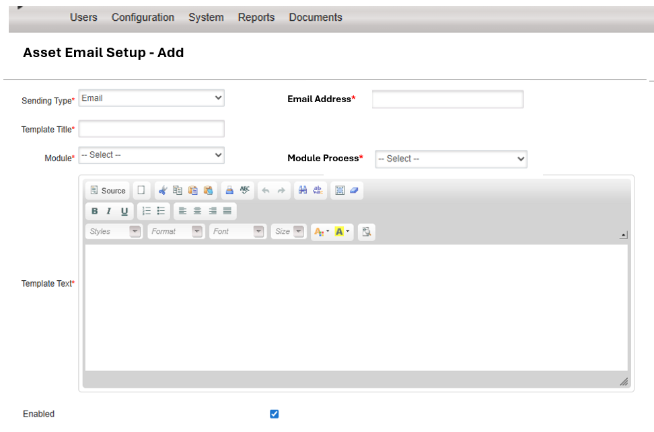

Create New Email Setup
The system must allow users to create a new email setup configuration.

Fields Required
Field Name | Type | Required | Description
Transaction Type | Dropdown | Yes | Asset process type linked to the email setup
Template Title | Textbox | Yes | User-defined email template title/subject
Recipient Email Addresses | Multi-entry Email Field | Yes | Multiple email addresses allowed
Email Message Content | Rich Text / Text Area | Yes | Email body content/template
Active | Checkbox | Yes | Indicates whether the setup is active

Transaction Type Dropdown Values
The following transaction types must be available in the dropdown:
- Depreciation
- Impairment
- Impairment Reversal
- Revaluation
- Prior Year Transactions
- Prior Period Transaction
- Disposal
- Transfer of Assets
- Asset Unbundling

Multiple Email Setups
The system must allow:
- Multiple email setups for different transaction types
- Multiple email setups for the same transaction type if required
Example:
- Two different email templates may exist for “Disposal”
- Each may have different recipients and message content

Email Recipient Management

Multiple Recipients
The system must allow users to enter multiple email addresses per setup.

Requirements
- Email addresses must be separated individually
- Validation must ensure valid email format
- Duplicate email addresses should not be stored

Email Template Configuration

Template Title
Users must be able to define a custom template title.
This value will be used as:
- The configuration name
- The default email subject line

Email Message Content
Users must be able to configure the email body content.

Requirements
- Multi-line text support
- Rich text editor support (recommended)

Edit Existing Email Setup
The system must allow users to:
- Search existing email setups
- Open and edit configurations
- Update recipients
- Modify template titles
- Modify email content
- Activate/deactivate setups

Delete / Deactivate Functionality

Recommended Approach
Instead of permanent deletion:
- Implement an Active/Inactive status
- Inactive setups must not trigger emails

Automated Email Triggering

Trigger Event
The relevant Asset sub-module process must automatically trigger the configured email notification after successful execution of the process.

Trigger Logic
When a transaction process is completed:
- Identify the transaction type
- Retrieve all active email setups linked to the transaction type
- Generate email content using configured template
- Send email to all configured recipients
- Log success/failure status

Triggered Processes
Emails must trigger for the following processes:
Transaction Type | Trigger Event
Depreciation | After depreciation process completion
Impairment | After impairment posting
Impairment Reversal | After reversal completion
Revaluation | After revaluation posting
Prior Year Transactions | After processing
Prior Period Transaction | After processing
Disposal | If the user selects “Yes” on the disposal screen to let Debtor know to open a Sundry Account
Transfer of Assets | After transfer completion
Asset Unbundling | After unbundling completion

Validation Requirements
Validation | Requirement
Mandatory Fields | Transaction Type, Template Title, Recipients, Message Content
Email Validation | Ensure valid email format
Duplicate Recipients | Prevent duplicates
Empty Templates | Not allowed
Active Setup Validation | Only active setups can trigger

Audit & Logging Requirements
The system should log:
- Creation of email setups
- Modifications to setups
- User who performed changes
- Date/time of changes
- Email sending success/failure
- SMTP/system errors

Security Requirements
Only authorized users with configuration permissions may:
- Create email setups
- Edit email setups
- Activate/deactivate setups
Recommended permission:
Asset Configuration Administration

Suggested Database Structure

Table: AssetEmailSetup
Column Name | Type
EmailSetupId | PK
TransactionType | varchar
TemplateTitle | varchar
MessageContent | text
IsActive | bit
CreatedBy | varchar
CreatedDate | datetime
ModifiedBy | varchar
ModifiedDate | datetime

Table: AssetEmailRecipients
Column Name | Type
RecipientId | PK
EmailSetupId | FK
EmailAddress | varchar

Acceptance Criteria
The feature will be considered complete when:
- Users can create email setups
- Users can edit existing setups
- Multiple recipients are supported
- Transaction type selection is available
- Emails trigger automatically after process execution
- Only active setups trigger emails
- Email failures are logged
- Security permissions are enforced

